Exercise 5. Training Regions

|  |  |
| --- | --- |
| Skills Acquired | Data Required |
| * Identify a model training region for your species |  |

As we discussed in lecture, determining an appropriate training region for your model can have a dramatic impact on how good the model is.

* *Draw your training region.*

On the map below, draw what you think would be a good training region for the model. Label it “My Training Region”. Why did you choose the area you chose? Are their features of the species’ natural history that help inform your choice?

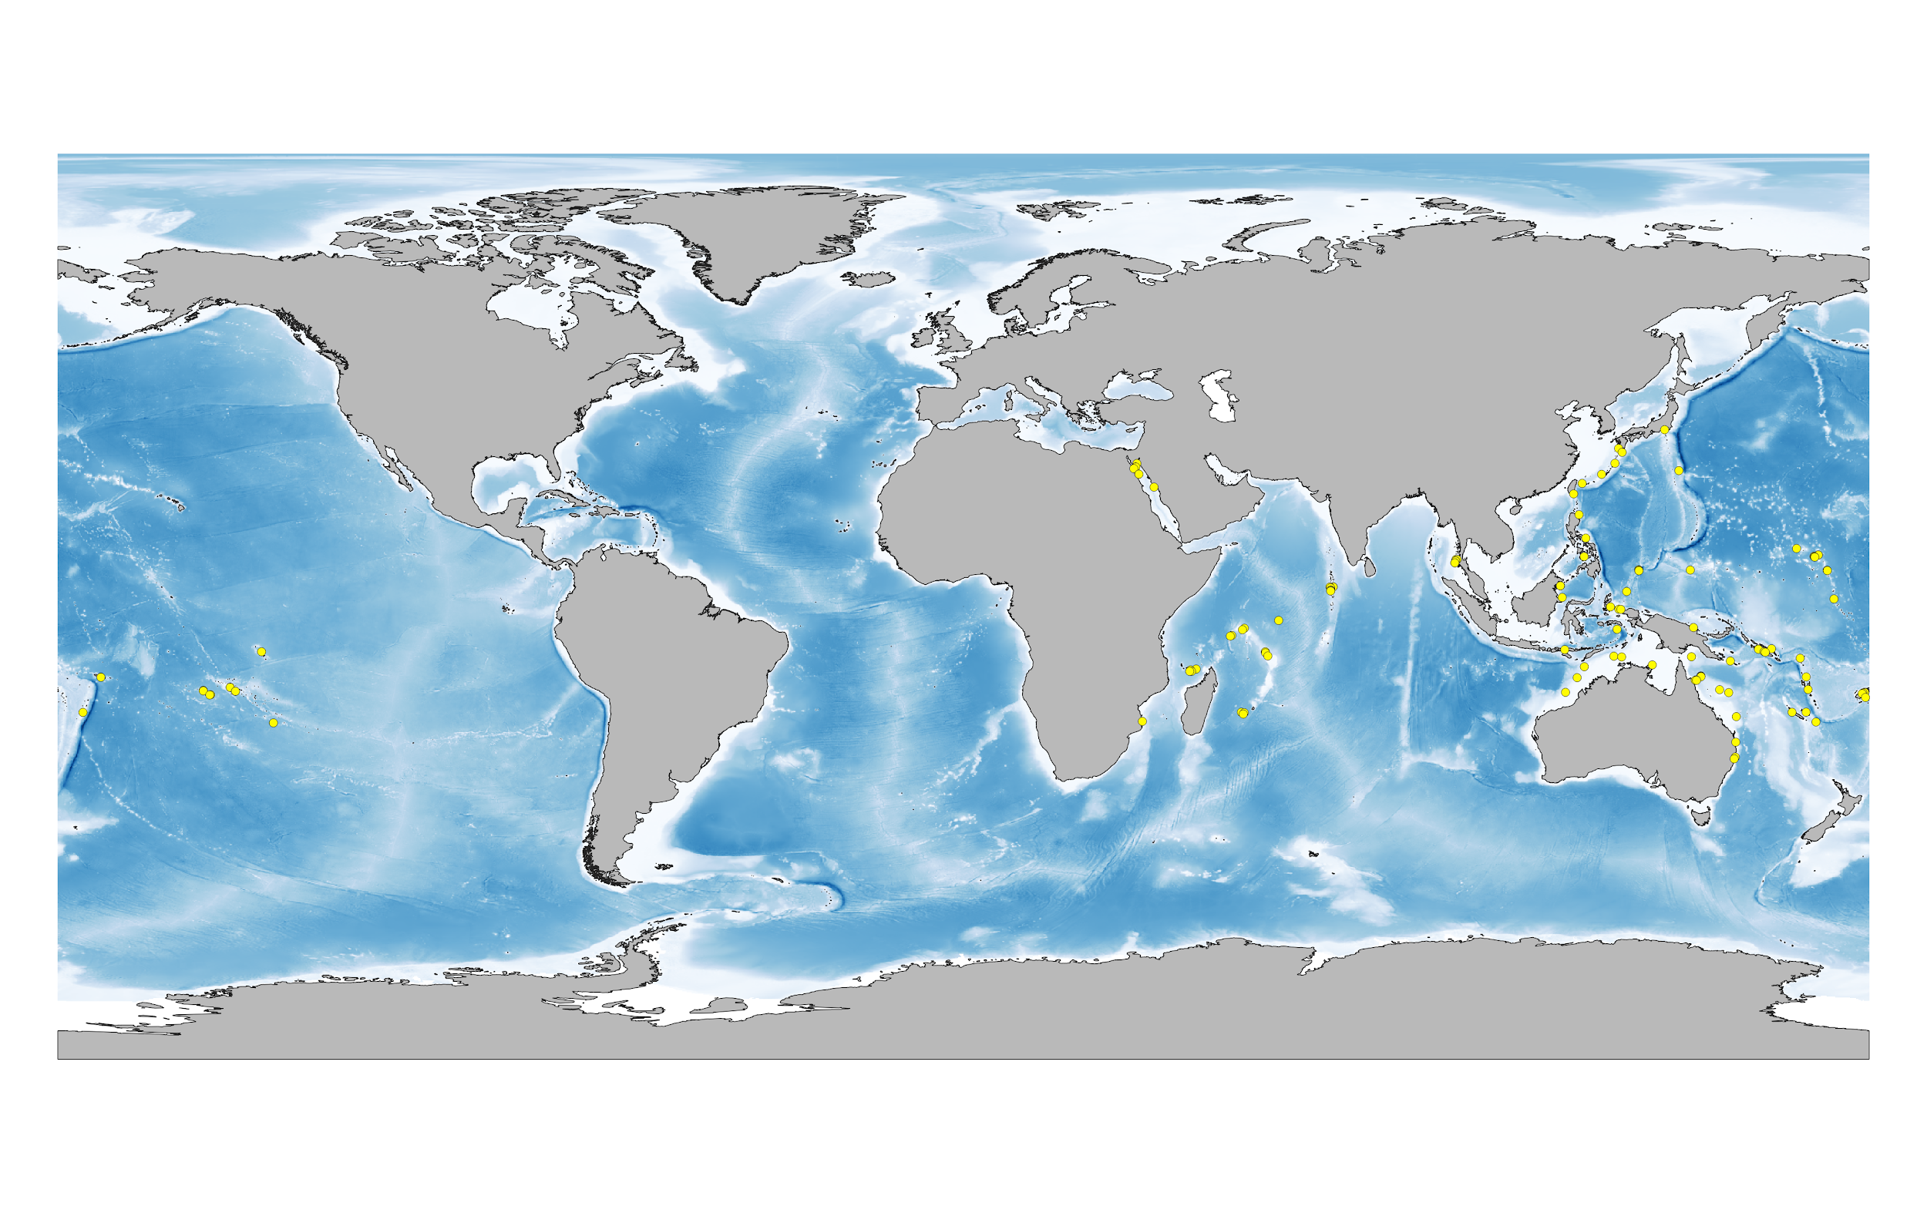

* *Compare your training region to the regions your groupmates chose.*

Did any of your groupmates choose a different training region than you, and how are they different? What was their justification? Try to reach a consensus training region as a group, and draw it on your map above as well. Label it “Group Training Region”.

* *Whole-workshop discussion.*

On the big map at the front of the room, draw your group’s training region and label it with your group name. How does it compare with the regions other groups selected? Now that you have heard the justification for calibration region designation for other groups, are there any changes you would make to your own?